Assignment 6: Calories and Carbohydrates Analysis

This report analyzes the relationship between calories and carbohydrates in Starbucks food items using the provided dataset. The analysis includes correlation, descriptive statistics, regression modeling, and interpretation of the findings based on outputs generated in JASP.

# 1. Pearson Correlation

The Pearson correlation coefficient between calories and carbohydrates is r = 0.675 (p < .001). This indicates a moderate to strong positive relationship. As calories increase, the carbohydrate content also tends to increase.

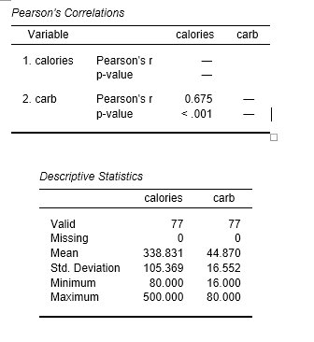

# 2. Descriptive Statistics

The mean calorie content is approximately 338.83 kcal with a standard deviation of 105.37. For carbohydrates, the mean is about 44.87 grams with a standard deviation of 16.55 grams. These values suggest a wide variety of items with differing nutritional contents.

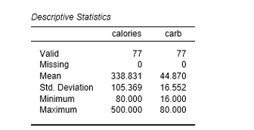

# 3. Regression Line

Using linear regression analysis, the equation to predict carbohydrates from calories is:  
carb = 8.94 + 0.11 × calories  
This equation indicates that for each additional calorie, the expected increase in carbohydrates is about 0.11 grams.

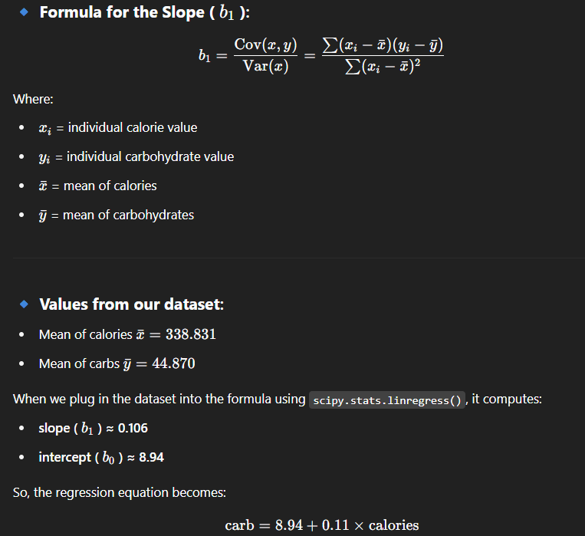

# 4. Model Validation and R²

The regression model was validated in JASP and yielded consistent parameters. The coefficient of determination, R², is 0.456. This means approximately 45.6% of the variation in carbohydrate content can be explained by the number of calories in Starbucks food items.